**Guide to compile and execute code/application**

The ‘Code’ folder in the submitted archive contains the necessary .m files while the audio signals used by us can be found in ‘Audio Files’ folder. However, this project should work fine with any audio signal sampled at 48kHz.

Please follow these steps to successfully execute the code.

* Open the file name ‘modulator.m’ in MATLAB editor.
* Make sure the working directory is the same as the ‘Code’ directory.
* Run the code.
* You should see a GUI as in the figure below

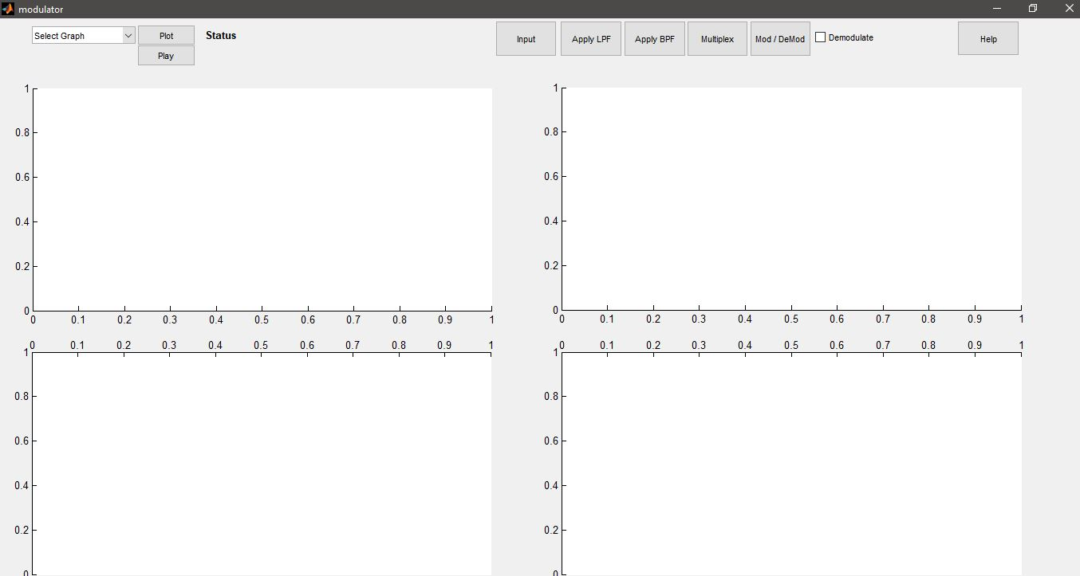

* Function of each button can be seen on it.
* To start processing the signals, click *Input* and select audio files. Make sure that you do not select more than 4 files otherwise they will be cropped to 4. Less than 4 files can be selected.
* You should now see the status of processing beside the *Plot* button.
* After processing, plots in time domain should be visible on the 4 graph objects.
* If you will now click *Apply LPF,* the signals should be low pass filtered and displayed on graphs.
* Then click *Mod/Demod* to modulate signals. Results should be visible afterwards.
* After that, click Multiplex to sum the signals and view summated signal.
* Now, to start the reception part, check the *Demodulate* checkbox
* Click *Apply BPF* to demux the signals and view results.
* Click Mod/Demod to demodulate signals and view results.
* Click *Apply LPF* to clear out high frequencies and view the final, received signal.

**Using the DROPDOWN menu**

The dropdown menu is filled with entries as you perform different operations. Each entry in the dropdown menu is named as ***<operation>Batch<Time/Freq><Number>***

***Operation:*** This can be *Input, LPF, Modulated, sum* etc depending on the operation.

***Time/Freq:*** After each operation, both the time and frequency domain representations of products are stored. Time/Freq indicates that.

***Number:*** Every time signals are input using *Input* button, they are treated as on batch and given a batch number for indentification.

By selecting entry from the dropdown list, you can plot it by clicking the *Plot* button, play the sound by clicking *Play* button. Moreover, any operation that you perform will be performed on the selected entry (if applicable).

**Dropdown example**

